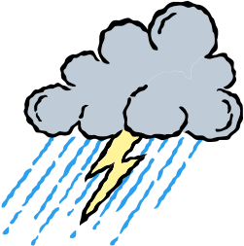Electricity Revision Sheet

- Draw a helium atom and label all the parts with their names and charges.

- Explain how static electricity is made? (Use the words “rub”, “electrons”, “atoms”, “positive”, “negative”)

- Name the three basic parts of an atom state their charge.

- Explain the ways in which objects can become charged? What is happening to the atoms of the object?

- What is the difference between voltage and current?

- What are each measured in?

- What does a voltmeter do?

- Why does hair stand up on end and separate out when a person is “charged up” with a Van de Graf Generator?

- Draw symbols for the following circuit parts:

- Cell

- Battery

- Light Globe

- Wire

- Switch

- Resistor (fixed)

- Draw both types of circuits and give advantages and disadvantages for each one:

- Series circuit

Advantages
Disadvantages

- Parallel Circuit

Advantages
Disadvantages

- How do these electrical safety devices work?

- Fuse

- Earth Pin (in a three pin plug)

- Plastic insulation around a wire

- Write 3 sensible electrical safety rules that would apply to around the home.

- Give definitions for the following electrical words and state what units we use to measure them with:

- Voltage:

- Current:

- Resistance:

